Cape Lookout Mobile Sportfishermen, Inc. – Application for membership

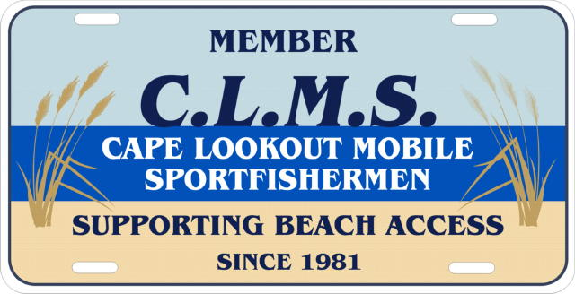

Name-Primary Member: ____________________________________________________________________ $35.00

Lifetime Membership _____________________________ $250.00

Spouse Membership-Name: ______________________ $15.00

Juniors (Ages 12-18) Name: Birthdate: $10.00

Name: Birthdate: $10.00

Youth Members (under 12) Immediate Family - Free – just give us their name and birthdate
Youth Life Memership (under 12) need name & birthdate $100.00

Amount Enclosed: __________________

Address:
Town: State: Zip Code:

Phone - Home ( ) Phone – Cell ( )

Email: Sponsor:

Dues for new member are $35.00, which includes a club license tag and decal. Spouse membership is an extra $15.00, and children 12 to age 18 can be members for $10.00 a year. Children age 12 to 18 with a paid membership can fish the regular tournaments by paying the entry fee, and the yearly drum contest in the adult category-no fee). Use the back of this form if more space is needed for children. We do need your child’s birth date. Dues are payable each year in January. If you join after October 1, your dues will cover the remainder of this year and also next year. Please mail your check (payable to C.L.M.S.) to: C.L.M.S., PO Box 222, Atlantic, NC 28511-0222

CLMS will sponsors a yearly membership drive starting January 1 through December 31.. Any member signing up three (3) new members will receive a free dues for the following membership year, and a chance to win a prize at the annual outing.

We are always looking for volunteers to help the club…. Please note which committees you would be interested in helping us out with.

Nominating ________ Fishing Tournaments ______ Annual Meeting _______ UMAPA Rep ___________

Membership _______ Take-A-Kid/Take-A-Vet Fishing ______ Newsletter _________ Sunshine _______

Fundraising ________ Community Outreach __________ Club Store _________

